Q2. Theory of Path Planning Algorithm

The AAE freshman project requires us to acknowledge basic programming skills in order to run these programs to bring benefits to the aviation industry. Path planning has always been an important concern for pilots before the flight, the route should always maintain high ‘efficiency’ by considering the distance, cost in several aspects and the safety issue. Therefore, the path planning algorithm which can provide the most efficient route in terms of all calculations within a short period is doubtlessly practical.

The name of the program is ‘A\* path planning algorithm’. The principle of this program is to convert the map into imagined coordinates in terms of the x-axis and y-axis, fixing the dimension of 1 grid, and calculate the shortest route between the starting point and the end point. Each specific coordinate is known as a node, in which the traveling distance must be 1 node in every algorithm calculation. Moreover, the ‘searching space’, which is the 8 extended directions with a node in the middle, is to identify the node which has the shortest ‘distance’ traveling to the goal node.

(Figure 1)

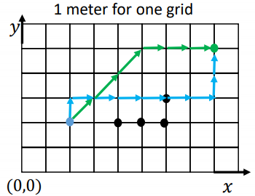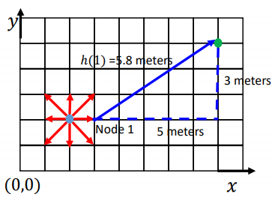

For example, according to the case in figure 2, the starting node of the route is at (2,2) , the first step of the algorithm calculation is occurred to search the corresponding node, of the 8 extended directions. If the algorithm selected the node which is straightly right to the starting node, the distance between the selected node and the goal node will be then calculated with Pythagoras theorem, which is 5.8 meters. However, if the algorithm chosen the node which is at the upper right corner, coordinate (3,3) , the distance between (3,3) and the goal node will be calculated again, which output a distance with 5.4 meters only, shorter than the previous calculation. Therefore, the first calculation result obtained by the algorithm will be a movement to the node at the upper right corner, which is identified as node 1. The algorithm will run for 8 times for each centered node, calculating the direct distance between the nodes and the goal point with purpose to select the route with the lowest cost, and eliminate the other choices.

After introducing the principle and working process of the algorithm, we have to know that the airplane could not fly in a straight line at all, as there might be different situations which conduct difficulties or benefits to the flight. The most common cost-consuming areas are the time-consuming area, and the fuel-consuming area. They represent situations like flying with a lower speed limited due to the air traffic control, and conditions like flying against strong wind velocity or wind slash which consume more fuel than usual. Therefore, these areas which require additional costs of the flight should also be added into the map design for the algorithm program to calculate.

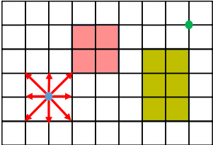

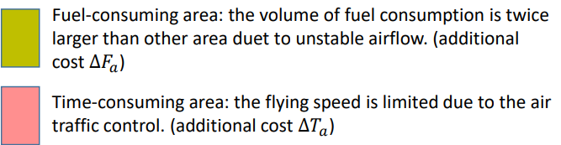

The most important function of the algorithm program after considering all different additional cost-consuming areas and route calculation is the final process of generating the shortest route, with the least possible cost consumed. The total cost of a route could be calculated with a formula which include the cost of fuel, time related cost per minute of flight, fixed cost independent of time, time related cost per minute of flight, trip fuel and trip time. The algorithm will then substitute all these data into the program which could calculate the total cost of the route for each aircraft.

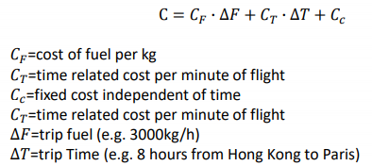

In conclusion, the A\* path planning algorithm is absolutely useful for pilots to plan the flight route, as the algorithm could generate the most appropriate and efficient route, in terms of the shortest distance and lowest cost required for the flight. The further development of these algorithms could be utilized in the aviation industry, as to benefit the industry by bringing improvement in service and facilities.